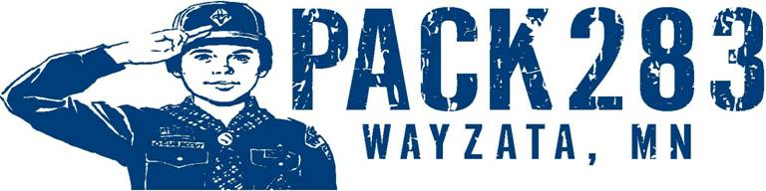

To parents of Bear Scouts in Den 5 & 8,

We will be presenting a special class on knife safety at Near Wilderness. The class is designed to teach the safe handling and proper care of pocketknives. This will fulfill Bear Achievement 19 – Shavings and Chips and allow Bears to earn the Whittling Chip card, which is required for any Cub Scout to carry a pocketknife at Cub Scout functions.

While I am sure some of you may be concerned with the idea of the boys carrying a pocketknife, this program is designed to teach knife safety. The class is important since most boys will use kitchen and other knives in the future. The actual Whittling Chip card will be given to the boys only with parental approval at the end of the class. When I’ve taught this class before, there has been no safety problems brought to my attention since the cards were issued. Again you will have the final say at the end of the class.

Besides the basic knife safety rules, the boys will learn these additional rules that must be followed.
1. They must have the card in their possession at all times while using a knife.
2. At any time Akela (any adult including parents) can ask for the card and it must be presented or the knife will be collected and returned to the parent.
3. No knife will be carried on school property at any time even by mistake. Violation of this rule means permanent loss of the card as well as any punishment from the school.
4. Any injury to another person will result in permanent loss of the card.
5. Any time a safety rule is violated, Akela may tear a corner off the card. Loss of all four corners result in the loss of the card which must be re-earned by attending and passing another Whittling chip class.

Due to safety concerns a parent or other adult must attend with each boy. This person will make the decision of whether or not the card will be issued. The following items should be brought to the class by the parent:
- A pocketknife (Does not have to be new but should be sharp and in good condition)
- Lawn Chair (The class will be held outdoors to allow more space for safety reasons)
We will have a few extra knives on hand to borrow, but given the number of Scouts, we will not have enough

If you have any questions about the class, please call me at (612)281-7501or by e-mail at scouterstu@comcast.net.

Stu Smith
Asst. Cubmaster & Pack Trainer, Pack 283

